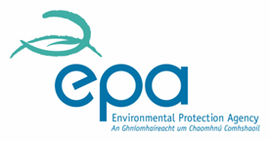

|  |
| --- |
| **FINAL**  **EPA Report on Progress by Local Authority with Noise Action Plans**  **Summary Review of Noise Action Plan Annual Reports for 2023** |

**December 2024**

ENVIRONMENTAL PROTECTION AGENCY

An Ghníomhaireacht um Chaomhnú Comhshaoil

PO Box 3000, Johnstown Castle, Co. Wexford, Ireland

Telephone: +353 53 916 0600 Fax: +353 53 916 0699

Email: info@epa.ie Website: www.epa.ie

Disclaimer

© Environmental Protection Agency 2024

Although every effort has been made to ensure the accuracy of the material contained in this report, complete accuracy cannot be guaranteed. Neither the Environmental Protection Agency nor the author(s) accepts any responsibility whatsoever for loss or damage occasioned, or claimed to have been occasioned, in part or in full as a consequence of any person acting or refraining from acting, as a result of a matter contained in this publication. All or part of this publication may be reproduced without further permission, provided the source is acknowledged.

Acknowledgements

The data presented in this report are based on the work of many organisations involved in noise action planning. These include the Local Authorities, along with some input from Transport Infrastructure Ireland, Iarnród Éireann and Dublin airport authority staff together with staff in the EPA Office of Radiation Protection and Environmental Monitoring (ORM) and their technical consultant Simon Shilton (Acustica EU Ltd).

1. **Introduction**

Under the European Communities (Environmental Noise) Regulations 2018, an annual Noise Action Plan progress report must be submitted to the EPA by each Local Authority by the 28th of February (each year). This Summary report provides an overview of the 2023 progress reports that were received and reviewed by the EPA in 2024.

The Environmental Noise Directive (END) is the main EC regulatory framework established to manage environmental noise, through harmonised procedures to assess levels of noise exposure, assess the impact on human health, and prepare noise action plans. Within the framework of the implementing Irish regulations, the END, and the context of sustainable development, the overall aim of managing environmental noise is to avoid, prevent and reduce the harmful effects due to long term exposure to environmental noise, which would in turn promote good health and a good quality of life.

Under Regulation 7 of European Communities (Environmental Noise) Regulations 2018[1] it states that the following shall be designated action planning authorities for the purpose of making and approving action plans, in consultation with the Agency and the noise mapping body for the noise map involved—

* for major railways, the local authority or local authorities within whose functional area or areas the railway is located.
* for major roads, the relevant local authority or local authorities within whose functional area or areas the road is located; and
* for major airports, the local authority or local authorities within whose functional area the airport is located.
* For the agglomeration of Cork:
  + Cork City Council; and Cork County Council.
* For the agglomeration of Dublin:
  + Dublin City Council; and the County Council of Dun Laoghaire/Rathdown, Fingal and South Dublin;
  + Kildare County Council; Wicklow County Council.
* For the agglomeration of Limerick:
  + Limerick City and County Council; and Clare County Council.

Article 12 (10) of the Regulations regarding Action Plans states:

“Action planning authorities shall report to the Agency on all actions taken under each action plan or revised action plan in the previous 12 months.”

1. **Assessment Criteria Used**

The Environmental Noise Directive (END) is one of the National Enforcement Priorities (NEPs) under the Air and Noise thematic area in the EPA Local Authority Environmental Enforcement Performance Framework[2]. In 2023 local authorities submitted Noise Action Plan (NAP) Progress Reports to the EPA to demonstrate progress under the ENDs National Enforcement Priority and the information was assessed according to the Local Authority Environmental Enforcement Performance Framework Assessment Methodology.

|  |
| --- |
| **Environmental Noise Directive Activities (ENDs)** |
| For 2023, the NEP progress in this area should address the following: |
| (i) **Submission of the local authority Noise Action Plan (NAP) Progress Report.** |

The assessment of the progress outlined in the Annual Noise Action Plan (NAP) Progress Report submitted to the EPA, as well as its subsequent review, are monitored and reported by the EPA under the Local Authority Performance Framework. The following table sets out the marking scheme under the framework.

**Table 1: Marking scheme used for Noise Action Plan (NAP) progress reports.**

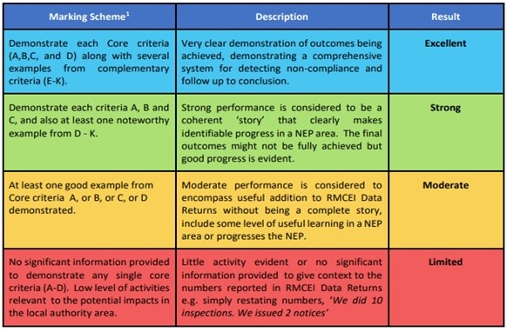

1. **Summary Assessment Findings for 2023**

A summary of the annual Noise Action Plan progress reports submitted for 2023 is provided in Table 2 below and in the map in Figure 1.

**Table 2: Summary Assessment of the 2023 Noise Action Progress Reports from Local Authorities**

|  |  |  |  |
| --- | --- | --- | --- |
| **No.** | **Rating Assessment by EPA** | **No. of LAs that submitted reports (31)** | **Local Authorities** |
| 1. | Excellent | **1** | Limerick City & County |
| 2. | Strong | **5** | Dublin City Council, Dun Laoghaire Rathdown County Council, Kerry County Council, Kildare County Council, and South Dublin County Council |
| 3. | Moderate | **19** | Cavan County Council, Clare County Council, Cork City Council, Cork County Council, Galway City Council, Galway County Council, Laois County Council, Leitrim County Council, Longford County Council, Louth County Council, Mayo County Council, Meath County Council, Monaghan County Council, Offaly County Council, Roscommon County Council, Sligo County Council, Tipperary County Council, Westmeath County Council, and Wicklow County Council. |
| 4. | Limited | **6** | Carlow County Council, Donegal County Council, Fingal County Council Note 1, Kilkenny County Council, Waterford City & County Council, Wexford County Council. |

Note 1: The Fingal County NAP (Including the airport) was rated as Limited. The Dublin airport NAP part of the report was rated as Moderate, but the overall result for Fingal County was Limited.

Most of the progress reported by the local authorities (LAs) has been around the use of low noise road surfaces, such as Stone Mastic Asphalt (SMA) and pavement rehabilitation, traffic calming measures to reduce speeds, noise monitoring surveys at some noise hotspots or the identification of potential Quiet Areas. There has also been a noticeable modal change to active travel which involves the prioritisation of cycling and walking routes in most of the LA areas.

In Limerick, the council has been in discussions with Transport Infrastructure Ireland (TII) about mitigation for the Ballycummin and Patrickswell priority areas which have previously undergone a noise mitigation assessment. Meanwhile 6 priority areas within Limerick City will now benefit from reduced noise because of a speed reduction to 30 km/h, while 6 new Noise and Air Quality monitoring stations were purchased and installed during 2023. A series of micro radars have been deployed around the city during 2023 to monitor vehicle movements. Several LAs including Kildare County Council have implemented some urban road pavement improvement schemes that have incorporated low noise surfacing.

For some local authorities, there were no specific Noise Action Plan related actions implemented in 2023. This would indicate that while many of the LAs are making steady progress there is still plenty of room for improvement. It is hoped that the new approach for the Round 4 noise action plans that has focused on priority important areas (PIAs) will allow for more effective noise mitigation and reduction in statistical data for people exposed to harmful effects, going forward. It is anticipated that the action planning authorities will need to concentrate on these PIA locations during the implementation of their Round 4 noise action plan.

Further overview details and data on the assessment of the progress reports from the individual local authorities is provided in Appendix 1.

**Figure 1: Summary Assessment of the 2023 Noise Action Progress Reports from Local Authorities**

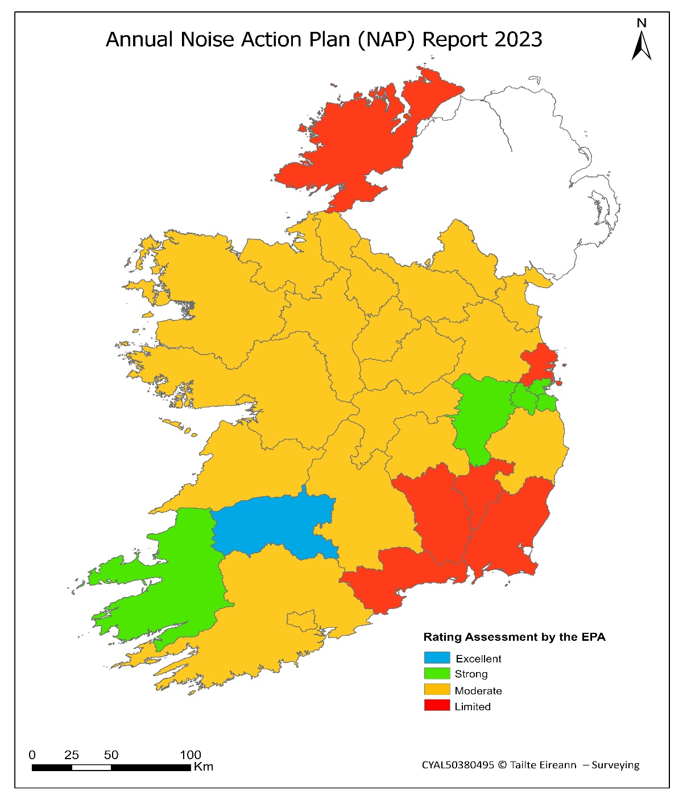 

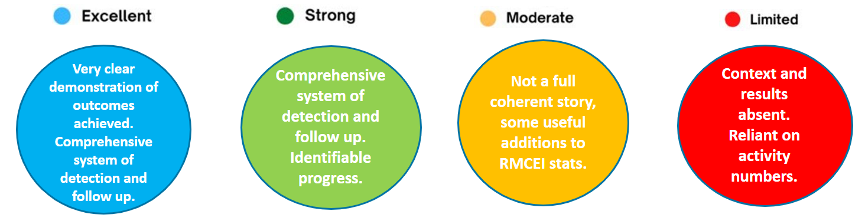

1. **Outlook to 2030**

Reducing noise pollution has become a significant environmental health concern for European citizens and policymakers, and it is an ambition of the European Union Zero Pollution Action Plan (ZPAP) and the Environmental Noise Directive (END). The ZPAP targets set to be achieved by 2030 include “reducing the share of people chronically disturbed by transport noise by 30%”, compared to 2017.

In support of ZPAP, the EU PHENOMENA project was undertaken to identify cost-effective noise mitigation measures which may help competent authorities to achieve noise reductions across large parts of the exposed population. The main obstacle to reaching the zero-pollution action plan target is the difficulty in reducing the large number of people exposed to road traffic noise. Reversing this would require significantly increased efforts to address noise from road transport. Based on the EPA review of the 2023 noise action plan progress reports (with summary details provided in Appendix 1), the EPA note the need for significant actions and investments to meet the aims and ambitions of the Environmental Noise Directive and the Zero Pollution Action Plan.

1. **Recommendations**

The EPA’s assessment of local authority performance in 2023 shows that some local authorities have still not prioritised implementation of actions under their noise action plans. From a review of the 2023 progress reports, the main recommendations for future consideration are as follows.

1. **Local Authority Performance Report 2023**[3]**:** Air and Noise is still the lowest performing enforcement priority across the Local Authority Performance Framework. Many local authorities struggle to implement their Noise Action Plans, as required under the Environmental Noise Regulations. The European Commission’s Zero Pollution Action Plan sets a target of reducing the negative impacts of exposure to transport noise by 30% by 2030. Local authorities will need to allocate adequate resources where relevant and collaborate with other key bodies especially Transport Infrastructure Ireland (TII), Irish Rail, and Dublin Airport Authority to prioritise and mitigate excessive noise exposure, particularly transport noise in urban areas, and designate quiet areas in cities for people’s health and wellbeing.
2. **Implementation of Noise Action Plans (NAPs)**: A new approach for the Round 4 NAPs involves the initial screening of noise exposed sites based on the results of strategic noise mapping. This process as outlined to LA during the development of the draft Round 4 Guidance Note for Noise Action Planning[4] identifies Important Areas (IA), most important areas (MIA), and priority important areas (PIA). The LA Round 4 noise action plans will need to be proactively progressed over the next 4 years if there are to be any significant reductions in noise exposure. A challenge here for local authorities is that the roles and responsibilities for implementation of transport noise mitigation across the noise mapping bodies, action planning authorities and departments is not clear. This is particularly the case for priority noise areas relating to national roads. As outlined above, LAs and other transport infrastructure bodies need to collaborate more effectively to deliver on noise prevention and mitigation by resourcing and implementing the Round 4 noise action plans.
3. **Regulatory Stakeholder Engagement:** It is very important to involve key stakeholders including the local authorities, Transport Infrastructure Ireland, Irish Rail, Dublin Airport Authority, Aircraft Noise Competent Authority and the Department of the Environment, Climate and Communications (as appropriate) in discussions and negotiations. This should help to ensure that there is a more proactive and strategic approach to discussions and collaboration around the funding of Priority Important Areas (PIAs) for noise action and to securing the associated funding requirements.

Noise management measures in the Noise Action Plans should reflect the wider context of local and national sustainable development plans, policies, and strategies such as the 2040 National Planning Framework (currently being revised), the Local development plan as well as sustainable transport and sustainable urban mobility strategies.

1. **Road Noise:** Road noise remains the largest source of harmful effects due to noise exposure across Europe and is likely to be the focus for noise mitigation actions in the coming years. According to the European Environment Agency, low noise tyres and pavements should be further promoted, as increased demand for such products will also drive tyre manufacturers and road contractors to innovate and make them available.

As noise pollution is a significant health issue, local authorities and other transport infrastructure organisations need to focus on noise prevention and mitigation, particularly in urban areas, by implementing noise reduction measures to reduce traffic noise as prioritised through the Noise Action Plans and by designating quiet areas in their cities.

1. **EEA Briefing Report – 2030 Outlook;** To reach the zero-pollution target (30% reduction by 2030), measures need to target populations in high noise hot spots (i.e. those with higher noise exposure levels) and those living in areas that are exposed to lower noise thresholds. Therefore, a combination of measures is needed, including better urban and transport planning, as well as significant reductions in road traffic. Other measures outlined in this EEA report include better acoustic design for developments, reduction in speed limits on roads, redesigning roadways using low noise road surfaces, a balanced approach around airport operations, and creating low noise emission zones and quiet areas.
2. **Noise Policy including REGAIN:** The Department of the Environment, Climate and Communications continues to progress a business case for an enhanced enforcement structure known as REGAIN to support the provision of improved coordination, expertise and advice to underpin the consistent implementation of environmental noise, noise nuisance and air quality legislation across the local authorities. Establishment of a suitable support structure will be essential in providing advice, guidance, training, advocacy and other supports, which would ensure a more consistent approach to air and noise enforcement and the successful undertaking of statutory functions such as the delivery of strategic noise maps, noise action plans and health assessments across the state. **Appendix 1 – Data collection and further overview details on the assessment of the progress reports from the individual local authorities.**

|  |  |
| --- | --- |
| **No. of Annual Action Progress Reports (2023)** | 31 received (out of 31 due to be submitted) |
| **No. Reviewed** | 31 |
| **Mapping & NAP Round** | 3rd Round ENDs |
| **Noise Action Plan Year** | 2023 |

|  |
| --- |
| **Excellent (1)** |
| * Limerick City & County Council (LCCC): The council has been in discussions with TII about mitigation for the Ballycummin and Patrickswell priority areas which have previously undergone a noise mitigation assessment. Noise monitoring was undertaken at Patrickswell priority area to confirm previous 2021 results. LCCC has reviewed the acoustic design of all planning applications for proposed dwellings and residential developments near major roads, having due regard to ProPG, BS 8233:2014 and WHO guidelines. Meanwhile, 6 priority areas within Limerick City will now benefit from a speed reduction to 30 km/h. It is planned to bypass the Oola priority area, work is ongoing on the design and EIAR. 6 new noise and AQ monitoring stations were purchased and installed during 2023. A series of micro radars have been deployed around the city during 2023 to monitor vehicle movements. Monitoring of sound levels at Candidate Quiet Areas (CQAs) has been undertaken. |
| **Strong (5)** |
| * Dublin City Council: Ensured that Noise Action Plan and related noise strategies were incorporated into the Dublin City Development Plan 2022-2028. In 2023 the Air Quality Monitoring and Noise Control Unit in consultation with the Planning Department wrote comprehensive noise control conditions for the construction and post construction phases of developments. This included improvements to the Unit’s Good Practice Guide for Construction and Demolition. Modal change to active travel though an integrated Active Travel Network. Prioritisation of cycle and walking routes. * Dun Laoghaire-Rathdown County Council: Five walking and cycling infrastructure schemes completed. Have developed specific guidance with respect to noise in the planning process. Electric vehicle parking is required in new developments. In addition, DLRCC is expanding its own fleet of EVs across our fleet. A number of schemes were completed in 2023 as part of the Road Resurfacing Programme Major Works using SMA road surfacing material to reduce the noise compared to HRA. * Kerry County Council: Have recorded 2 to 3 dBA reduction when SMA was used as replacement road surface for two priority locations identified using scoring matrix. Approximately 105 properties and 315 residents benefited. Additional sites identified, funding committed, and works commenced. A bypass in the centre of Listowel that will reduce noise exposure for 125 receptors is expected to be completed in June 2024. * Kildare County Council: 2023 Delivery (roads opened), including Athy Inner Relief Road. Preopening noise level taken for comparison with post-opening. Urban area of Athy noise environment greatly improved. 8000 veh/day removed from urban centre. Low noise surfacing on bypass. Hotspot monitoring /Verification Noise measurements- completed on M4/M7. Low Noise Surfacing to replace existing noisier surfaces – Motorway M4 outbound completed from Maynooth to Leixlip. Liaison with TII ongoing. Low Noise Surfacing to replace existing noisier surfaces in urban areas ongoing. * South Dublin County Council: Began upgrading 5 of 11 permanent noise measurement terminals. 12 meetings with developers within pre-planning process for large developments near major roads. 62 road resurfacing projects completed using SMA 14 and SMA 10. 9 Candidate Quiet Areas (CQAs) identified under R4, consultation with Parks Division ongoing. Bus priority route, including possible new barriers, on M4/N4 under development, with Junction 6 to 5 from Celbridge to Leixlip completed in 2023. |
| **Moderate (19)** |
| * Cavan County Council: Three schemes, approx. 10 km, resurfaced on N3, N54 and N55 with funding from TII. The identification and assessment of potential quiet areas continued in 2023. Two active travel projects delivered to help support modal shift. * Cork City Council: 17 schemes to enhance walking, cycling and use of public transport were delivered. Progress continued on CCMS and CMATS modal shift policies. Significant progress was made in delivering non-physical policy measures during 2023, which will result in reduced traffic related noise levels, however no examples provided. Climate Strategy and Air Quality Strategy may benefit noise. * Clare County Council: Traffic reduction measures included within Clare CC climate action plan 2024-2029. Re-surfaced sections of road with Clause 942 (14mm) thin layer surface – this will provide slightly lower noise emissions than HRA, including parts of: R469 (900m), R463 (830m), R458 (808m), R458 (1022m). TII resurfaced N18 Bunratty to Jn 4 with SMA * Cork County Council: N22 Ballyvourney to Macroom bypass now fully opened (part opened in 2022). 16 properties required noise mitigation, 98 experienced a reduction due to bypass opening. Dunkettle interchange resurfaced with “low noise road surface” to reduce noise. * Galway City Council: Noise policy statements included in County Development Plan. 30 km/h speed limits introduced in the city centre in August 2023. Road resurfaced using SMA. Traffic counts undertaken to support TII R4 mapping. Review of R3 NAP commenced Q4 2023. Several active travel and cycle network routes developed to help support modal shift. * Galway County Council: Works on construction of N59 Moycullen Bypass competed in Q4-23 which has reduced traffic volumes passing through the village and noise for approx. 140 dwellings, 500 people with approx. 2 dB reduction. Lower noise SMA on R446 Oranmore, benefiting 120 properties, around 500 people, with estimated 3 dB reduction. Noise monitoring surveys undertaken during Q4 adjacent to R446 Oranmore and M6 Ballinasloe. * Laois County Council: SMA used to resurface approximately 8.5km of road on N77 and N80 which will help reduce noise levels. Installation of EV chargers within the county to promote use of EVs. Laois Co Co have introduced a cycle to work scheme and facilitate home working and teleconferencing. Construction of 3 active travel safe routes to schools. Junction tightening to reduce traffic speeds at 6 sites. Review of traffic flows and speeds on Regional and Secondary routes. * Leitrim County Council: 12 active travel projects were completed in 2023 providing improved footpaths, 4 more were started in 2023. NAP included in county Development Plan 2023 – 2029, including 4 noise related policies, and an objective to implement the NAP. LCC Roads office staff attended 9 meetings with TII and RMO during 2023 in connection with noise maps and action plans. * Longford County Council: N63 in Longford (Major Wells Road) was reconstructed in 2022 and the final surface course was placed in January 2023. Surface course used was Stone Mastic Asphalt (SMA). The old N4 road in Edgeworthstown from C + D Foods to the junction of pound street was resurfaced using SMA. Cycle Tracks constructed on N63 Ballinalee Rd. and R198 Battery Rd into Longford town. This will hopefully create a shift from vehicles driving to people cycling/walking thus reducing road noise. * Louth County Council: Resurfacing R166 Scarlett Street Drogheda with SMA. Resurfacing roads with SMA, including R171 Dundalk, R168 Trinity Street. Construction of PANCR (Port Access northern cross route) in Drogheda ongoing, due to open in 2024, noise level changes will be assessed after opening. Liaison with traffic and housing to identify projects for lower noise road surfaces or retrofitting of double glazing. * Mayo County Council: SMA has been used to resurface sections of N84, N26, N5, R332, R373 and L1615 replacing HRA providing an expected 2-3 dBA reduction for an estimated 1,000 people. * Meath County Council: Within urban areas the Council continues to use low noise surfacing as part of its annual roadworks programme. Over 35,000m2 (up to 5km of 2 lane road) of SMA was laid in 2023 in the County. This includes roads in larger settlements Dunshaughlin, Navan, Trim and Ratoath. The Council continues to add to the list of housing estates with a 30kph speed limit. 20 number housing estates were added to 30 kph byelaw in 2023. The Active Travel team have progressed over 35 projects, to deliver on cycling, walking and public transport initiatives and infrastructure. * Monaghan County Council: A review of noise complaints at some properties along the N2 route took place in 2022: Property 1 (Monanny): Mitigation was agreed with TII during 2023 and work to install a noise barrier commenced. Property 2 (Clontibret); Maintenance of an existing noise barrier will be undertaken during 2024. The proposed N2 road realignment project between Ardee and Castleblayney will examine the noise implications of the project as part of the design. * Offaly County Council: Noise control and management is incorporated into Tullamore, Birr and Edenderry Local Plans which were adopted in 2023. R402 Edenderry bypass reduced noise levels in Edenderry for an estimated 400 people by 2 to 5 dBA. Sections of M6 motorway noise barriers have been extended, repaired and replaced. Speed limits are currently under review, which may help reduce noise levels. Greenways and cycleways are being expanded to help with modal shift away from cars. * Roscommon County Council: Lower noise road surface installed, 200m of SMA low noise road surfacing completed on N4 Cortober, to county boundary with Leitrim at Carrick on Shannon. New HRA surface installed, 6kms of HRA surfacing completed on N61 from Bogganafin roundabout at M6 slip road west to Ballybay. The new surface is expected to reduce impact noise generated by surface imperfections. Inter-departmental working group established to deliver R4 NAP. * Sligo County Council: Resurfaced and replaced faulty ironworks on chapel hill in 2023. This road faces directly onto Mercy College. Result is reduction in noise at Mercy College, approx. 450 students. Road re-surfacing with lower noise pavements. Various Active Travel measures. Resurface a section of the N4 with SMA is due to be completed in 2024. Resurface a section of the N15 with new HRA is due to be completed in 2024. A section of the R287 was resurfaced with SMA between 2021 and 2023. * Tipperary County Council: have implemented a number of urban pavement improvement schemes that have incorporated low noise surfacing. These include the N24 in Carrick on Suir and Tipperary Town, the N52 in Thurles and the N76 at Grangemockler. Each of these also include traffic calming. The noise reduction is estimated at 3 dB Lden for up to 3,000 people. The implementation of Noise assessments during the planning approval stages is continuing. The NAP working group continue to meet to progress the implementation of the NAP. Further implementation of actions contained within the NAP is ongoing. Improved Traffic management has been implemented with further projects currently in planning. * Westmeath County Council: A ‘Hot Spot’ identified in the NAP (N6 Athlone) has been designated as a priority. A noise survey was carried out in Jan 2023. The installation of any mitigation measures identified, will be subject to funding (TII role). 10 active travel schemes completed to encourage modal shift. Athlone Bus Eireann fleet now electric. Inter-departmental coordination and consultation between transport, planning, climate change and active travel. * Wicklow County Council: Resurface sections of M/N11 and R761 with SMA. Carry out End of Plan Review to assess progress in implementation of Action Plan in Q1 of 2023. Ensure financial provisions are in place to produce new Noise Action Plan 2023. Continue to Liaise with the M11/N11 Corridor (J4 M50 – J14 Coyne’s Cross) Works Project Team on noise related issues. Continued liaison with Dublin City Council (as lead authority) in the preparation of the Dublin Agglomeration Noise Action Plan. |
| **Limited (6)** |
| * Carlow County Council: No specific actions identified or implemented. * Donegal County Council: No specific actions identified or implemented. * Fingal County Council: For most of the county (except for the airport) there was no progress reported against the NAP implementation plan, and there is no update on any other noise measures. So, the overall rating for Fingal County is limited. In relation to Dublin airport, have an increased number of monitoring terminals with results available near-live via WebTrack. Annual noise contour maps published. * Waterford City & County Council: Replacement of old HRA road surfaces with 10mm SMA in urban areas, such as Regional Roads at Airport Rd, Dunmore Rd and Ash Rd, and local roads at Anne Street, Ballybricken, Connolly Place, German Rd., Matties Hill. No other actions identified. * Wexford County Council: No new NAP actions undertaken in 2023. Seven potential Quiet Areas in urban areas were identified in 2022, but there has been no additional progress during 2023. * Kilkenny County Council: No specific actions identified or implemented. |

1. <https://www.irishstatutebook.ie/eli/2018/si/549/made/en/print> and Environmental Noise Regulations 2021; [S.I. No. 663/2021 - European Communities (Environmental Noise) (Amendment) Regulations 2021 (irishstatutebook.ie)](https://www.irishstatutebook.ie/eli/2021/si/663/made/en/print)
2. <https://www.epa.ie/our-services/compliance--enforcement/support-and-supervision-of-local-councils/la-performance/>
3. Focus on Local Authority Environmental Enforcement Performance Report 2023 - [Local Authority Environmental Enforcement Performance Report 2023 | Environmental Protection Agency](https://www.epa.ie/publications/compliance--enforcement/public-authorities/local-authority-environmental-enforcement-performance-report-2023.php)
4. The Round 4 NAP guidance note is expected to be finalised and published in 2024.